**Internship Report**

**Project Title:** Emotion Recognition from Text using Fine-Tuned DistilBERT with LoRA

**1. Introduction**

This report outlines the project Emotion Recognition from Text, which focused on fine-tuning a pre-trained language model (DistilBERT) using LoRA (Low-Rank Adaptation). The project involved classifying input sentences into one of 12 different emotion categories.

**2. Project Objectives**

* Develop an emotion recognition system based on natural language input.
* Fine-tune a lightweight transformer model (DistilBERT) for this classification task.
* Implement LoRA to optimize training and reduce resource usage.
* Evaluate model performance using F1-score and confusion matrix.

**3. Tools and Technologies Used**

* Python
* Hugging Face Transformers
* PyTorch
* LoRA via PEFT (Parameter-Efficient Fine-Tuning)
* Google Colab
* Scikit-learn
* Matplotlib

**4. Dataset**

The dataset used contained thousands of text samples, each labeled with one of 12 emotion categories:

1. Joy
2. Sadness
3. Anger
4. Fear
5. Surprise
6. Disgust
7. Love
8. Optimism
9. Pessimism
10. Trust
11. Anticipation
12. Neutral

**5. Methodology**

**5.1 Model Selection**

DistilBERT was selected due to its efficiency and lower computational requirements compared to BERT.

**5.2 Fine-Tuning with LoRA**

LoRA was applied to reduce training overhead. Only a small number of trainable parameters were introduced, significantly lowering memory usage.

Key configurations:

* Rank (r): 8
* Alpha: 16
* Target Modules: Query, Key, Value and Dense projection layers

**5.3 Training Details**

* Epochs: 5
* Batch Size: 16
* Learning Rate: 3e-5

**6. Evaluation Metrics**

**6.1 F1 Score**

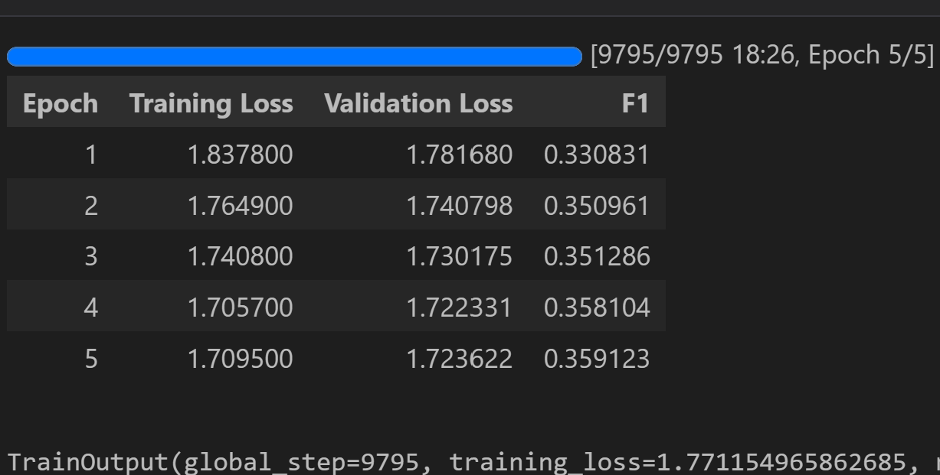

**6.2 Confusion Matrix**

A confusion matrix was generated to visualize the classification performance and highlight any misclassifications.

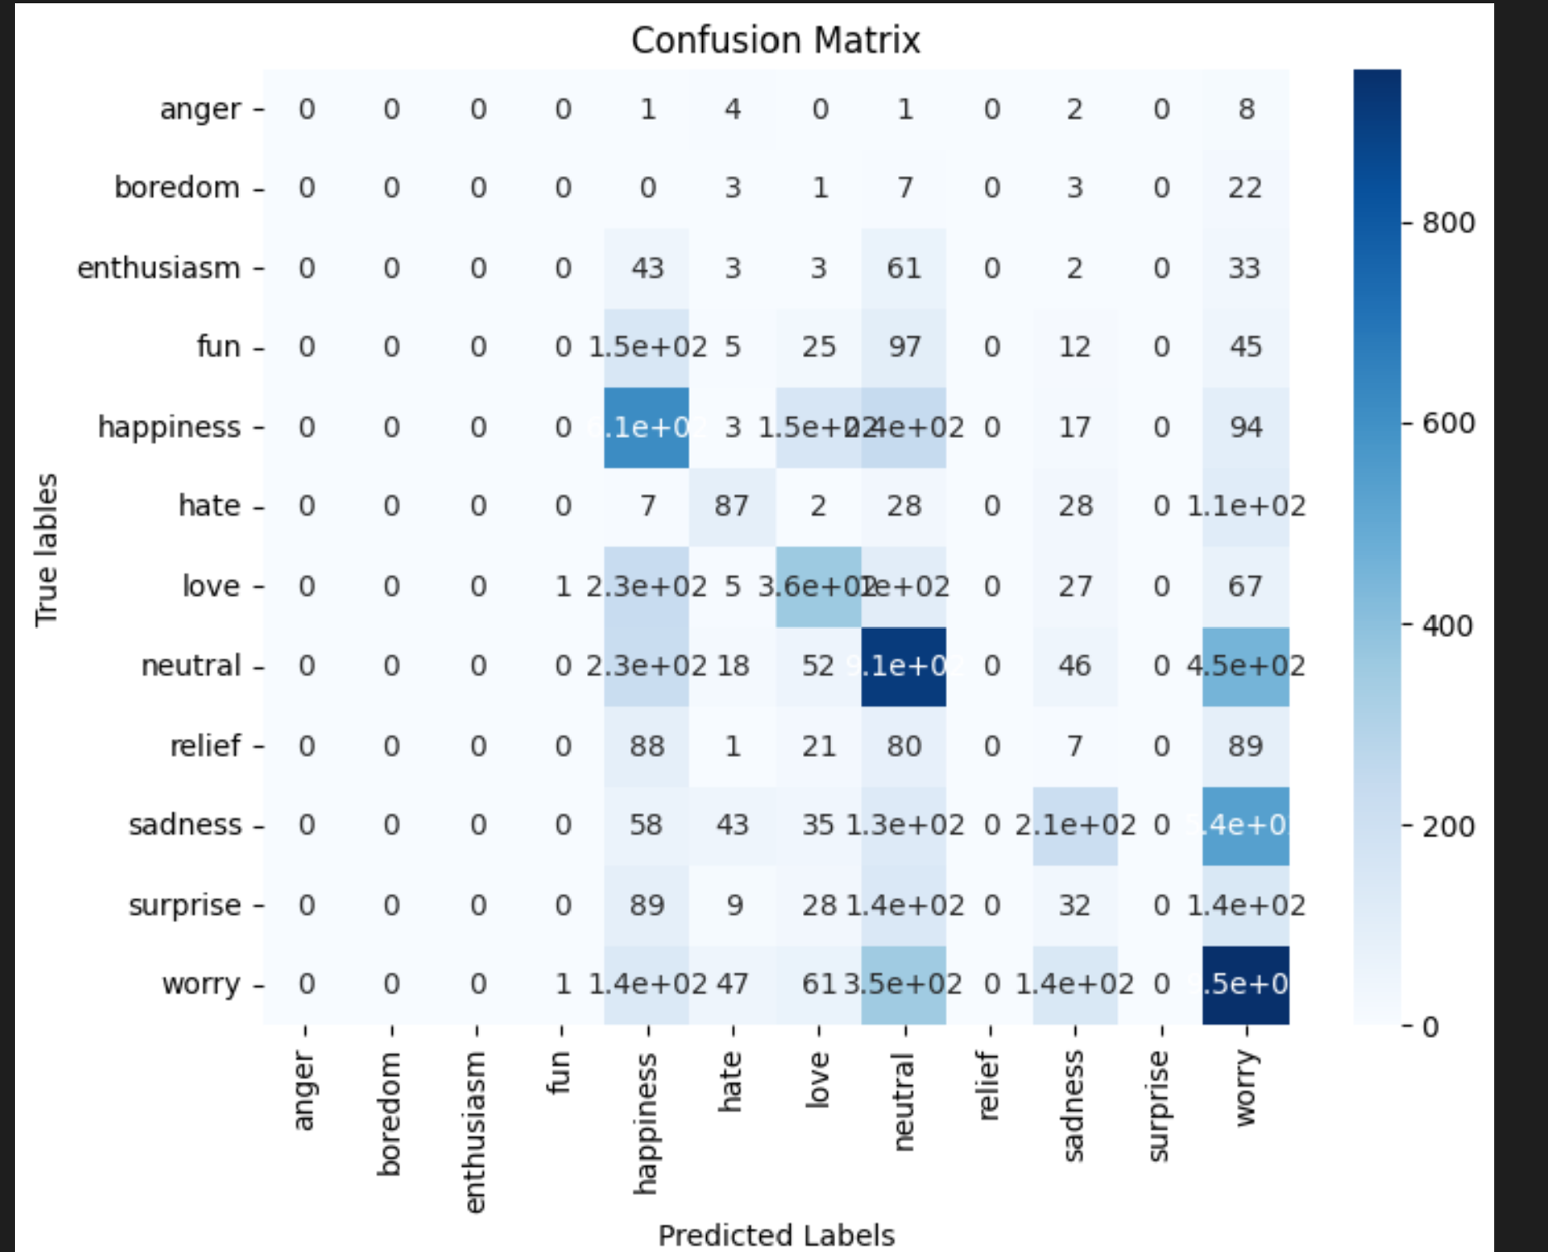

**7. Key Learnings**

* Gained hands-on experience with transformer models and LoRA-based fine-tuning.
* Learned how to evaluate classification models using F1-score and confusion matrices.
* Understood the importance of parameter-efficient fine-tuning in low-resource settings.

**8. Challenges Faced**

* Training large models on limited hardware.
* Tuning LoRA parameters for optimal performance.

**9. Conclusion**

The internship provided a valuable experience in applying advanced NLP techniques for emotion recognition. The use of LoRA allowed efficient fine-tuning of DistilBERT, maintaining strong performance while conserving computational resources. The project successfully demonstrated the ability to classify text into 12 distinct emotional categories with satisfactory accuracy.